#include <stdio.h>
#include <stdlib.h>
#define SIZE 5

int queue[SIZE];
int front = -1, rear = -1;

void insert(int item) {
if ((front == 0 && rear == SIZE - 1) || (rear + 1) % SIZE == front) {
printf("Queue Overflow\n");
} else if (front == -1) {
front = rear = 0;
queue[rear] = item;
printf("Element Inserted: %d\n", item);
} else {
rear = (rear + 1) % SIZE;
queue[rear] = item;
printf("Element Inserted: %d\n", item);
}
}

void delete() {
if (front == -1) {
printf("Queue Empty\n");
} else if (front == rear) {
printf("Element Deleted: %d\n", queue[front]);
front = rear = -1;
} else {
printf("Element Deleted: %d\n", queue[front]);
front = (front + 1) % SIZE;
}
}

void display() {
if (front == -1) {
printf("Queue Empty\n");
} else {
printf("Queue Elements: ");
int i = front;
while (1) {
printf("%d ", queue[i]);
if (i == rear) break;
i = (i + 1) % SIZE;
}
printf("\n");
}
}

int main() {
int choice, a;

while (1) {
printf("1.insert\n2.delete\n3.display\n4.exit\n");
scanf("%d", &choice);

switch (choice) {
case 1:
printf("Enter element to insert: ");
scanf("%d", &a);
insert(a);
break;

case 2:
delete();
break;

case 3:
display();
break;

case 4:
exit(0);

default:
printf("Invalid choice\n");
}
}
}

OUTPUT:

1.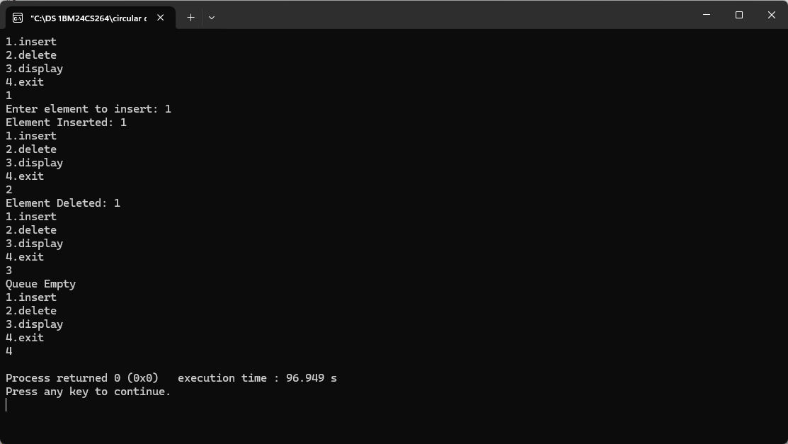2.